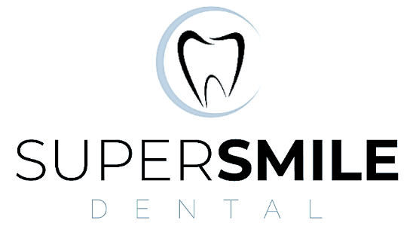
339 Cowbridge Road East
Canton
Cardiff
CF5 1JE
Tel: 02920233307

Statement of Purpose
Super Smile Dental
Prepared in accordance with the Regulated Services (Service Providers and Responsible Individuals) (Wales) Regulations 2017
Effective Date
1 March 2024
Review Date
Annually or sooner if there is a significant change to the service.
1. Service Provider Details
Practice Name: Super Smile Dental
Practice Address: 339 Cowbridge Road East, Canton, Cardiff, CF5 1JE
Registered Provider: Dr Ali El Maadarani
Responsible Individual: Dr Ali El Maadarani
Registered Manager: Dr Ali El Maadarani
Principal Dentist / Clinical Lead: Dr Ali El Maadarani
2. Purpose of the Service
Super Smile Dental is a mixed NHS and private dental practice providing high-quality, safe and patient-centred dental care to adults and children in Cardiff and the surrounding communities. The practice delivers preventative, restorative and cosmetic dentistry in accordance with current professional guidance and the standards expected by Healthcare Inspectorate Wales (HIW), the General Dental Council (GDC) and NHS Wales.
3. Philosophy of Care
• Place patients at the centre of all decisions.
• Provide safe, effective and evidence-based care.
• Promote prevention and long-term oral health.
• Treat every patient with dignity, respect and compassion.
• Maintain high standards of professionalism, governance and confidentiality.
• Continuously improve through audit, training and patient feedback.
4. Description of the Regulated Service
Services include:
• General dentistry
• Preventive dentistry
• Dental hygiene services
• Restorative dentistry
• Crowns, bridges and dentures
• Root canal treatment
• Tooth extractions
• Cosmetic dentistry
• Dental implants
• Orthodontics
• Facial aesthetic treatments
5. Patients Served
Adults, children and patients with disabilities. Care is provided without discrimination in accordance with the Equality Act 2010.
6. Facilities
The practice comprises three fully equipped dental surgeries, reception and waiting area, decontamination facilities, wheelchair access, accessible WC and appropriate emergency equipment and medicines.
7. Opening Hours
Monday: 9:00 am–1:00 pm; 2:00 pm–5:00 pm
Tuesday: 9:00 am–12:30 pm; 1:00 pm–3:00 pm
Wednesday: 9:00 am–12:30 pm; 1:00 pm–3:00 pm
Thursday: 9:00 am–1:00 pm; 2:00 pm–6:00 pm
Friday: 9:00 am–1:00 pm; 2:00 pm–4:00 pm
8. Languages
English, Arabic, French and Lithuanian. Interpreter services can be arranged where appropriate.
9. Accessibility
Wheelchair access and accessible WC. Reasonable adjustments are made for patients with additional needs.
10. Staffing
The practice is led by Dr Ali El Maadarani and supported by appropriately qualified dentists, dental nurses, hygienists/therapists and administrative staff.
11. Patient Assessment and Treatment
Patients receive an individual assessment, explanation of treatment options, risks, benefits and costs where appropriate, and valid informed consent before treatment.
12. Quality Assurance and Clinical Governance
Quality is maintained through clinical audit, policy review, continuing professional development, patient feedback, incident reporting and regular governance activities.
13. Infection Prevention and Control
The practice follows current national guidance for decontamination, hand hygiene, PPE, waste management, waterline maintenance and equipment validation.
14. Safeguarding
The practice has safeguarding policies for children and adults at risk. Staff receive appropriate safeguarding training and follow local referral procedures.
15. Confidentiality and Information Governance
Patient information is managed in accordance with UK GDPR, the Data Protection Act 2018 and NHS confidentiality requirements.
16. Complaints
Complaints should be directed to:
Dr Ali El Maadarani
Registered Manager
Super Smile Dental
339 Cowbridge Road East
Canton
Cardiff CF5 1JE
17. Out-of-Hours Arrangements
When the practice is closed, the answerphone provides advice together with NHS out-of-hours and emergency contact numbers.
18. Equality, Diversity and Welsh Language
The practice promotes equality, dignity and respect for all patients and supports the principles of the Welsh Language Standards.
19. Review
This Statement of Purpose is reviewed annually or sooner if there are significant changes to the service or regulatory requirements.
Approved by:
Dr Ali El Maadarani
Registered Provider / Responsible Individual / Registered Manager

